High Power Polarization Maintaining Isolator
(HI Series)

Features
High Isolation.
Low Insertion Loss
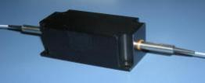
Low Polarization-related Losses Compact
High stability and reliability

Application
Optical Fiber Amplifier
Metro Area Network
Wavelength Add/Drop
Dispersion Compensation

Performance Specifications

Parameters | Specifications | Unit
Center Wavelength (λc)+ | 980 | nm
Operating Wavelength Range | λc ± 10 | dB
Typ. Peak Isolation | 30 | dB
Min. Isolation, λc, 23 ℃, all polarization states | 25 | dB
Typ. Insertion Loss, 23 ℃ | 0.8 | dB
Max. Insertion Loss, 23 ℃ | 1 | dB
Min. Return Loss (Input/Output) | 45/45 | dB
Min. Extinction Ratio | 20 | W
Max. Average Optical Power | 20 | ℃
Max. Peak Power for ns Pulse | 10 | ℃
Fiber Type | PM 980 Fiber
Fiber Length | 1.0 or customize | m
Connector | Customize
Package size | 64×28×26 | mm
* The temperature measurement environment is at 23℃
**If the connection head is increased, the insertion loss increases by 0.3dB and the return loss decreases by 5dB, which is reduced by 2dB for the protection product

Hirundo Optics Inc
Factory:2nd Floor, Building 6, #16 Xinfa Road, Southern Cable Industrial Park, Rongli Ronggui Street, Shunde District, Foshan city, Guangdong 528305 China
1
Tel: 0757-26619220 Email: info@hirundo-link.com Website：https://www.hirundo-link.com/


High Power Polarization Insensitive 1064nm
(TGG Based)

Mechanical Dimensions

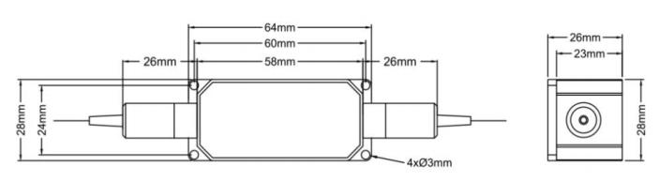

Order information:
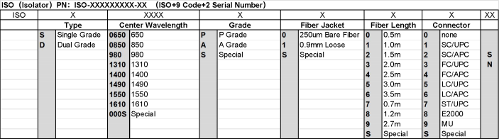

Hirundo Optics Inc
Factory:2nd Floor, Building 6, #16 Xinfa Road, Southern Cable Industrial Park, Rongli Ronggui Street, Shunde District, Foshan city, Guangdong 528305 China
2
Tel: 0757-26619220 Email: info@hirundo-link.com Website：https://www.hirundo-link.com/

